Zepp Z User Guide
Contents
Zepp Z User Guide 1
Getting Started 4
Appearance 4
Power On and Off 4
Charging 4
Wearing and Replacing the Watch Strap 5
Connecting & Pairing 5
Updating the System of Your Watch 7
Control Center 7
Time System 7
Units 7
Common Operations 7
Functions Available When the Watch Is Connected to the Phone 9
App Alerts 9
Find Mobile 10
Find Watch 10
Watch Face 11
Watch Face Compilations 11
Always On Display 11
Add Watch Faces 12
Change Watch Faces 12
Delete Watch Faces 12
Shortcuts 14
Smart Assistant 14
Quick Access Apps 14
Press the Lower Button 15
Workout 16
Workout 16
Workout GPS Positioning 16
Workout Reminders & Settings 17
Workout Control 18
Viewing Workout Records 19
Activities and Health 20
PAI 20
Activity Goal 20
Idle Alerts 21
Heart Rate 21
Heart Rate Alerts 22
All-Day Heart Rate Monitoring 22
Manual measurement 23
Sleep 23
Sleep Assistant 23
Sleep Breathing Quality Monitoring 24
SpO₂ 24
Precautions for SpO2 Measurement 25
Stress 25
Voice Function 27
Offline Voice 27
Online Voice 28
Watch Apps 30
Watch Apps 30
App List Management 30
Events 30
Weather 31
Compass 31
Barometric Altimeter 32
Alarm 32
Timer 33
Countdown 33
System Language Settings 34
Wearing Direction 34

Getting Started

Appearance

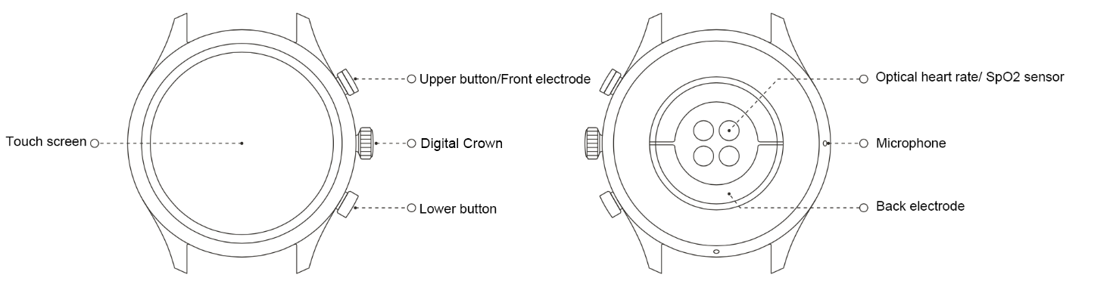

Power On and Off
Power on:
Press and hold the digital crown to power on the watch. The start screen will appear. If the start screen does not appear after you press and hold the crown, charge your watch and try again.
Power off:
Press and hold the digital crown for 5 seconds to access the power-off menu, where you can power off or restart your watch.
Force shut down:
Press and hold the digital crown for 10 seconds to force shut down.

Charging
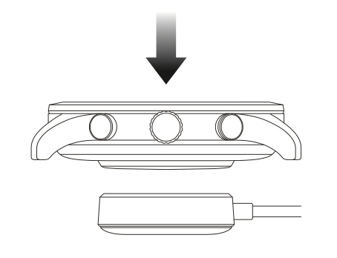
This watch is charged using a magnetic charging dock. As shown in the following figure, place the bottom of the watch on the charging base, and then connect the USB interface to the power adapter or the USB interface on the computer for charging. After charging starts, you will see the charging symbol on the watch face .
Note:
Please use the charging base provided with the watch. Ensure that the charging base is dry before charging.
We recommend that you use a power adapter with a 1A current.

Wearing and Replacing the Watch Strap
Do not wear the watch too tightly or loosely. Ensure that you both feel comfortable and that the sensor can work properly.
When measuring blood oxygen saturation (SpO2), avoid wearing the watch on the wrist joint, maintain a comfortable (appropriately tight) fit between the watch and the skin of your wrist, and keep your arm flat and still throughout the measurement process. When affected by external factors (such as arm sag, arm sway, arm hair, and tattoos), measurement results may be inaccurate or the measurement may fail with no output.
When measuring ECG, wear your watch on the wrist selected on your mobile app, maintain a distance from any powered on electronics, ensure that the backplate is in close contact with your wrist and the front electrode is in close contact with your fingers, and remain relaxed and still during the measurement.
You can tighten the watch strap during workout and loosen it afterwards. Tighten the strap appropriately if your watch sways on your wrist or fails to output data.
To remove and replace the strap, see the following figure.
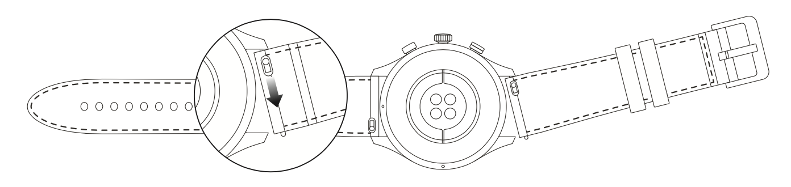
Note:
Once the strap is attached, pull the strap using appropriate force to ensure secure attachment.
Avoid contact with liquid, as the leather strap is not waterproof. Switch to a fluororubber strap or a silicone one if you cannot avoid such contact, for example, when swimming.

Connecting & Pairing
Use your mobile phone to scan the following QR code to download and install the Zepp app.
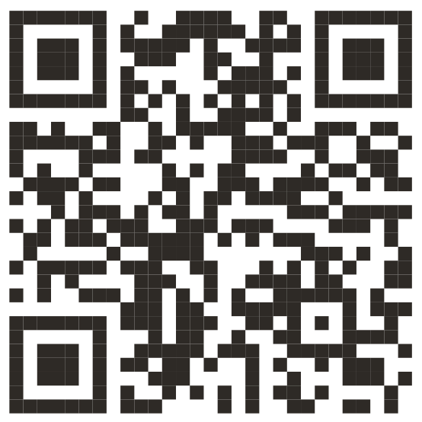
Note: The operating system of your mobile phone must be Android 5.0 or iOS 10.0, or higher.

Initial pairing:
When the watch is started for the first time, the QR code used for pairing is displayed on the screen.
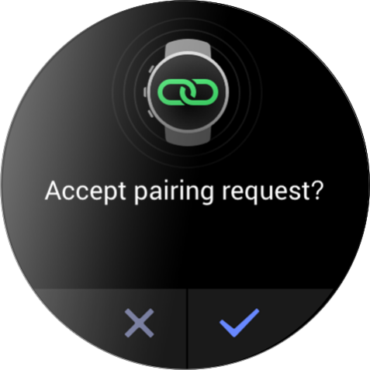
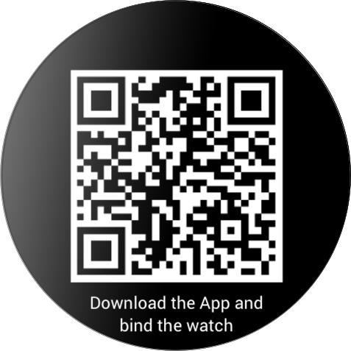
Start and log in to the Zepp app, and then scan the QR code displayed on your watch to bind your watch.

Pairing with a new phone:
- Launch the Zepp app on your old phone, and synchronize data with the watch.
- On your old phone, go to the device page, and tap Unpair at the bottom of the page to unpair the watch.tap More at the bottom of the page, and unpair the old phone from the watch.
- After unpaired, you can pair the watch with your new phone as indicated in the initial pairing procedure. Also you can restore the watch to factory settings directly to pair the watch with your new mobile phone.

Updating the System of Your Watch
Keep your watch connected to your mobile app, start the Zepp app, and choose Profile > Zepp Z > System update to view or update the watch system.
We recommend that you tap Update Immediately when your watch receives a system update message.

Control Center
On the watch face page, swipe down to go to the control center for the following system functions: Flashlight, Brightness adjustment, DND, Battery saver mode, Screen lock, Find mobile, Theater mode, and Keep screen on.
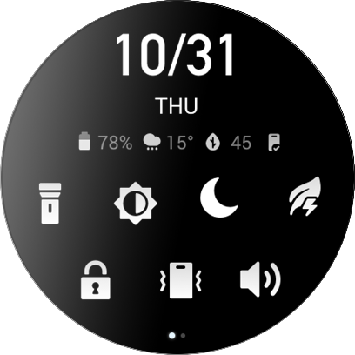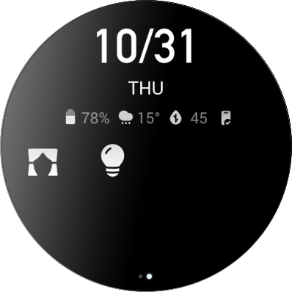

Time System
Keep the watch connected to your phone. During data synchronization, the watch automatically follows the system time and time format of your phone, and displays the time in a 12 h or 24 h format.

Units
Keep the watch connected to your phone, launch the Zepp app, and choose Profile > Settings. Then, you can set the unit for distance, weight and temperature. During data synchronization, the watch automatically follows the settings in the app.

Common Operations
Tap the screen | To enable this function, select the current item, or proceed with the next step.
Press and hold your finger to the watch face | to activate Watch face selection and Watch face settings
Cover the screen | Turn off the screen
Swipe up, down, left, or right | to scroll on the page or switch pages. On some pages, you can swipe right to return to the upper-level page.
Press the digital crown | Wake up the watch, and go to the app list or return to the watch face
Press the lower button | Start a particular app
Press and hold the digital crown for 1 second | Wake up online audio
Press and hold the digital crown for 5 seconds or more | Power on, access the restart page, and force restart

Functions Available When the Watch Is Connected to the Phone

App Alerts
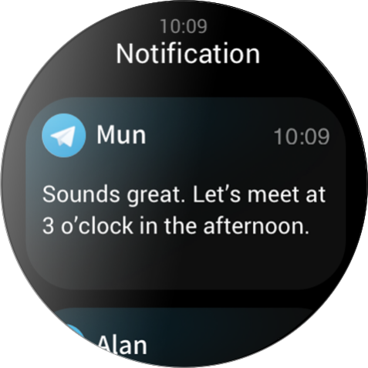
Keep your watch connected to the mobile app to receive mobile notifications on your watch. On the watch face page, swipe up to access the notification center and view the latest 20 notifications.
Setting method:
Keep your watch connected to the mobile app, start the Zepp app, choose Profile > Zepp Z and enable the notification function for apps.
Note:
To use this function on a mobile phone running Android, set the Zepp app to the whitelist or auto-run list and keep the app running in the background. If the Zepp app is killed by the phone's background process, the watch will be disconnected from your phone, and you cannot receive app notifications on the watch.

Incoming call
Keep the watch connected to the phone to receive incoming call alerts on the watch. You can choose to answer the call on the phone or hang up on the watch.

Modify settings on an Android phone:
Keep the watch connected to the phone, start the Zepp app, and choose Profile > My devices > Zepp Z > Notifications and reminders > Incoming call. Tap the "Please grant phone permission" message on the top of the screen. In the Grant Phone Permission dialog box, grant call permission to the Zepp app. If the message does not appear, the Zepp app has been granted the phone permission.
Note:
To enable this feature on an Android phone, you need to add the Zepp app to the whitelist or auto-run list in the phone's background so that the app always runs in the background. If the Zepp app is killed by a background process of the phone, the watch is disconnected from the phone and cannot receive incoming call alerts.

Find Mobile
- Keep the watch connected to your phone.
- On the watch face page, swipe down to go to the control center, and tap Find mobile. Your phone will vibrate and ring.
- In the app list, click Widgets, and tap the Find mobile button. Your phone will vibrate and ring.

Find Watch
Keep your watch connected to your phone. Start the Zepp app, choose Profile > Zepp Z, and tap Find watch. Your phone will vibrate.

Watch Face

Watch Face Compilations
Some watch faces support compilations. With compilations, you can view information such as steps, calories, and weather, or tap a compilation to launch the corresponding app. You can also edit information as needed.
Edit watch face compilations:
- Wake up the watch face, and press and hold the watch face page to go to the watch face selection page.
- Swipe left or right to preview the watch faces available to the watch. The Edit button will be displayed at the bottom of a watch face that supports setting the watch face. You can tap this button to go to the page for editing the compilations of this watch face.
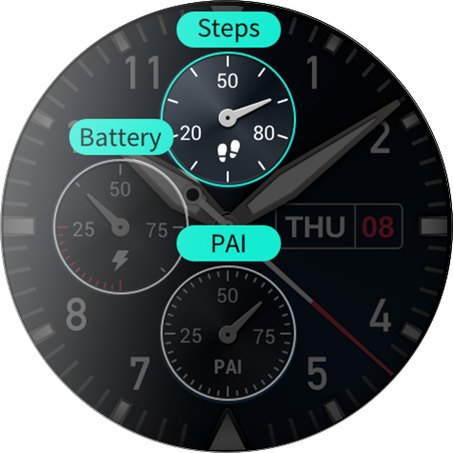
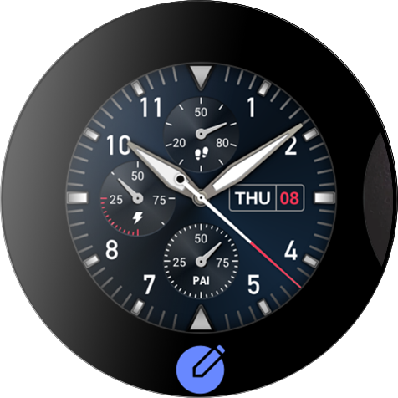
- Select the compilation to be edited, and tap this compilation, or swipe up or down on the screen to switch between compilations.

- After editing, press the digital crown to enable this watch face.

Always On Display
If this function is enabled, the screen still displays some information in standby mode, which greatly reduces battery life.
Set Always On Display:
- After you wake up your watch, press the digital crown to access the app list. Then choose Settings > Display and brightness > Always On Display.
- Select the watch face style and enable status for Always On Display.

Add Watch Faces
In addition to the built-in watch faces, you can choose online watch faces from the watch face store in the Zepp app and synchronize them to the watch. You can also set your phone images as custom watch faces with the app.
Add online watch faces:
- Keep your watch connected to your phone. Start the Zepp app and choose Profile > Zepp Z > Store.
- Select one or more watch faces, then synchronize them to the watch to give yourself multiple options.

Add customized watch faces:
Keep your watch connected to your phone. Start the Zepp app, choose Profile > Zepp Z > Store, and switch to a custom watch face.

Change Watch Faces
- Wake up the watch face, and then press and hold the watch face page to go to the watch face selection page.
- Swipe left or right to preview the watch faces available to the watch, including built-in watch faces and synchronized online watch faces.
- Tap the desired watch face to replace the current watch face with the desired one.

Delete Watch Faces
When storage space on the watch is running out, you will need to delete some of the watch faces to make room for new ones (some build-in watch faces cannot be deleted).
- Wake up the watch face, and press and hold the watch face page to go to the watch face selection page.
- Swipe left or right to preview the watch faces available on the watch, including built-in watch faces, synchronized online watch faces, and customized watch faces.
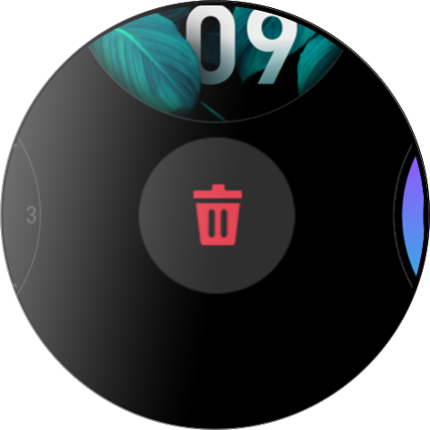
- Press and hold the watch face you want to delete, and then swipe up on the screen. A delete button appears if the watch face can be deleted. Tap to delete it.

Shortcuts

Shortcut Cards
Swipe right on the watch face to go to the shortcut cards page, which supports the easy use and view of various functions and information:
- View real-time app information, such as progress information for workouts and countdowns, which automatically appears on the shortcut cards page.
- View information about items and resident apps, such as your next scheduled event, alarm, and recent heart rate data.
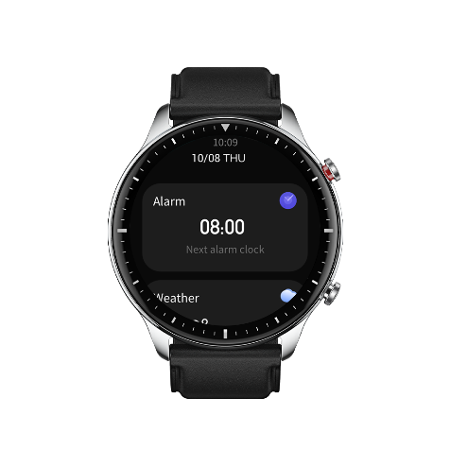
You can also start the Zepp app and choose Profile > Zepp Z > Open Shortcut Cards, where you can set the contents displayed and the order in which they are displayed.

Quick Access Apps
Quick access apps shown on the left side of the watch face offer you convenient access to watch functions. You can add your frequently used applications and functions, such as Workout.
Change quick access apps:
- After waking up the watch, press the digital crown to open the application list, choose Settings > User preferences > Quick access app, and swipe up and down to view the applications that can be added.
- When the value number of Current apps reaches the upper limit, remove the redundant apps and add the ones you need.

Press the Lower Button
Press the lower button to start a pre-configured app. The "Workout" app is opened by default. You can also replace it with an app that you frequently use on the Settings page.

Workout

Workout
The watch supports 12 workout modes, including outdoor running, walking, outdoor cycling, treadmill, indoor cycling, open water swimming, pool swimming, elliptical trainer, climbing, trail running, skiing, and free training.
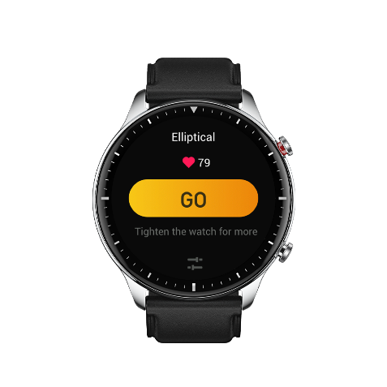
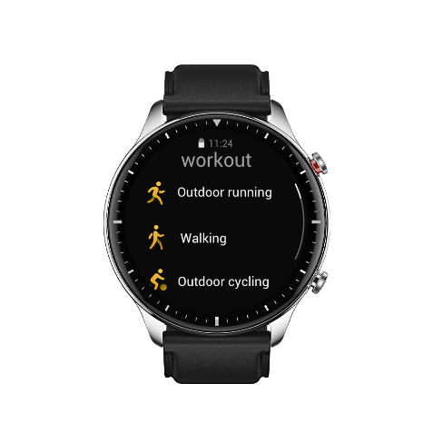
Wake up the watch, press the digital crown to go to the app list, select Workout, and tap the workout mode you wish to use. Then tap GO on the workout preparation page to start recording your workout

Workout GPS Positioning
If you do outdoor exercise, wait on the workout preparation page until GPS positioning is successful. Then tap GO to start the workout. This helps avoid tracking loss to guarantee complete and accurate workout data recording.
Positioning guide:
- If you are prompted to update the Assisted GPS (AGPS) after you select an exercise, start the Zepp app on your phone and connect it to your watch to update AGPS. Then, select an exercise again. This reduces the time spent searching for a signal and avoids search failure.
- During the positioning process, the GPS signal icon continues to flicker, an open area can offer you faster positioning for better GPS signal, as nearby buildings may block and weaken the signal, extending the positioning time and even causing positioning failure.
- After successful positioning, the GO button is highlighted. The GPS signal icon shows the current GPS signal strength.
AGPS is a kind of GPS satellite orbit information which helps the watch accelerate the GPS positioning process.
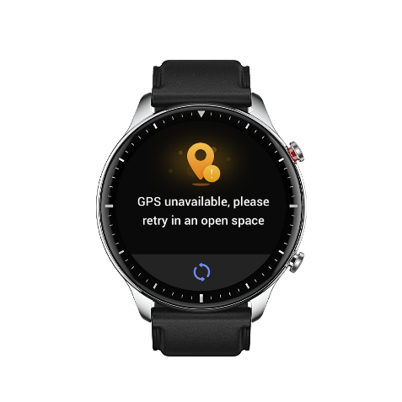
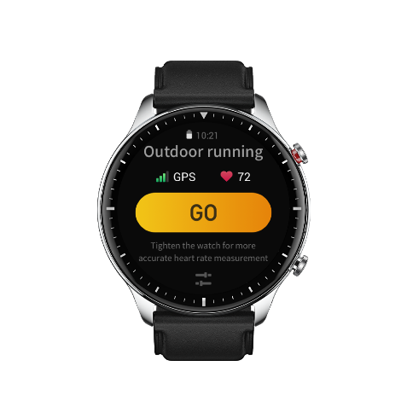
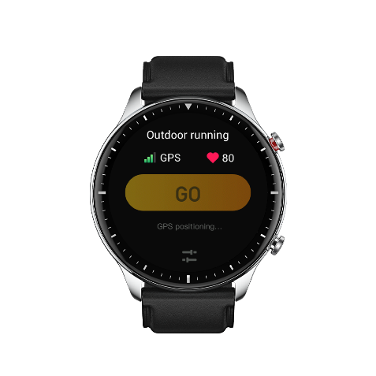

Workout Reminders & Settings
At the bottom of the workout preparation page, tap the "Settings"icon to set the current workout mode. The related parameters vary depending on the workout mode.
Workout goal:
Set goal reminders for the target distance, target time, and target consumption.
Workout reminder:
Set reminders for distance, safe heart rate, heart rate zone, pace, and speed.
Auto pause:
The watch automatically detects the workout status. When the watch detects that the workout has stopped, it automatically stops recording information about the current workout. When the watch detects that the workout has started again, it continues to record the workout information.
Real-time graph:
You can set the watch to display a real-time graph of the heart rate, pace, speed, and pull speed rate during your workout.
Lane length:
You can set the length of swimming lane during pool swimming to record swimming distance.

Workout Control
Enable the workout app to run in the background:
- During a workout, if you need to use other functions, press the digital crown to return to the watch face page and perform other operations. The workout app will continue running in the background.
- When the workout app runs in the background, the watch will continuously record workout data and generate reminders based on the workout settings.
- When the workout app is launched again, the watch automatically goes to the ongoing workout.

Play music:
Swipe left on the screen to control music playback on the phone apps during your workout.
View data:
During a workout, you can swipe up or down on the screen to view different data.
Control workout:
Swipe right on the screen to pause or continue workout, end workout, lock the screen, or adjust watch volume during a workout.
Save workout data:
When you stop a workout, the workout data is not saved if the distance or workout time is too short. Due to limited storage space, it is recommended that you synchronize workout data to the Zepp app soon after completing a workout. Otherwise, the workout data may be overwritten.

Viewing Workout Records
View workout records on the watch:
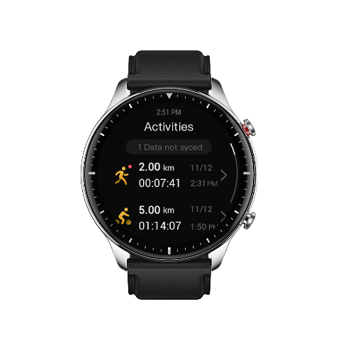
Wake up the watch, press the digital crown to go to the app list, and select Activities to view the latest 30 workout records. You can also select a record and view its details.
View workout records on the phone:
On the workout record page, you can view details about workout records that have been synchronized to the app.

Activities and Health

PAI
PAI is used to measure a person's physiological activity and reflect overall physical condition. It is calculated based on a person's heart rate, the intensity of daily activities, and physiological data.
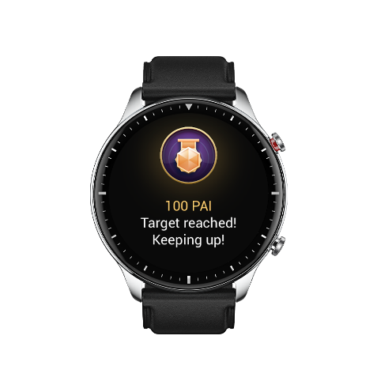
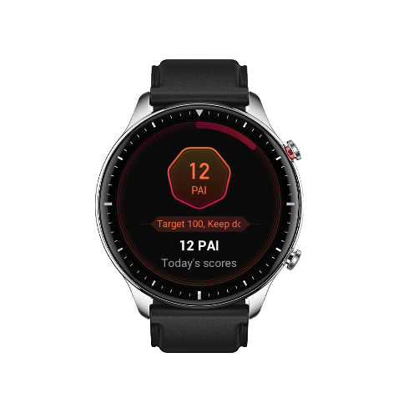
By maintaining a certain intensity of daily activity or exercise, you can obtain your PAI value. According to the results of the HUNT Fitness Study*, maintaining a PAI above 100 helps reduce the risk of cardiovascular death and increase life expectancy.
For more information, start the Zepp App and choose PAI cards > About PAI.
*The HUNT Fitness Study is a sub-project of the HUNT study, led by Professor Ulrik Wisloff at the School of Medicine, Norwegian University of Science and Technology. It has lasted over 35 years and involved more than 230,000 participants.

Activity Goal
The watch automatically records your activity data, including steps, calories, standing count, and distance. It also records the duration that heart rate is maintained within or above the fat-burning range as an index of fat-burning time.
- Your daily activity goal consists of three parts, including Move ring (with target steps or calories), Fat burning ring, and Stand ring.
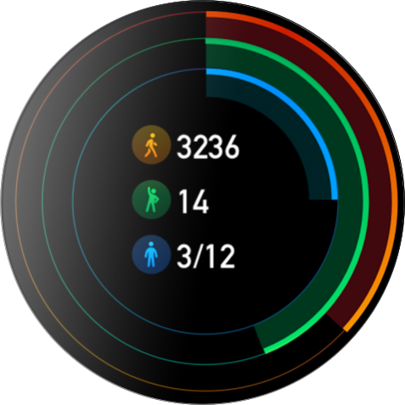
- When a target is achieved, the watch vibrates to congratulate you.

Idle Alerts
To encourage you to have a certain amount of activity every hour when you are awake and reduce the harm caused by sitting for too long, the watch monitors your activity as you wear it.
If no activity is detected for more than 1 min at the 50th min of the current hour and you are properly wearing the watch, the watch will vibrate to remind you to do some exercise. After receiving an idle alert, if you complete activities before the next hour arrives, the stand-up target of the current hour can still be achieved.
Enabling idle alerts:
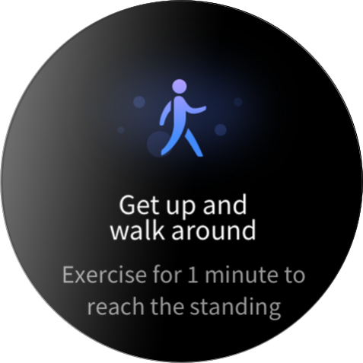
Keep your watch connected to your phone. Start the Zepp app, choose Profile > Zepp Z > Notifications and reminders, and enable the idle alert function.

Heart Rate
Heart rate is an important indicator of physical condition. Highly-frequent heart rate measurement helps capture more heart rate changes and provide a reference for a healthy lifestyle.
To ensure measurement accuracy, you need to wear the watch correctly according to the instructions, and ensure that the portion next to your skin is clean and free of sunscreen smear.

Heart Rate Alerts
If the Automatic Heart Rate Detection is enabled and the detection interval is set as within 10 minutes, you can enable the heart rate alert function.
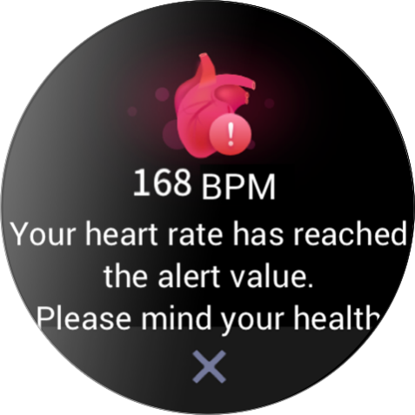
The watch vibrates when the alert value is reached and there is no obvious activity detected in the last 10 min.

Automatic Heart Rate Detection
- Keep your watch connected to your phone. Start the Zepp app, choose Profile > Zepp Z > Health Monitoring, enable Automatic Heart Rate Detection, and set the measurement frequency. The watch automatically detects the heart rate according to the set frequency and records your heart rates throughout the day.
- Heart rate can change dramatically when you are doing an activity. If you enable heart rate monitoring, the watch automatically increases heart rate measurement frequency to record heart rate change when it detects activity.
- The watch's heart rate app allows you to view the heart rate curve and heart rate distribution throughout the day.

Manual measurement
- To measure your heart rate manually when Automatic Heart Rate Detection is not enabled, wake up the watch, press the digital crown to go to the app list, and then swipe up or down to select the heart rate app.
- Set the heart rate app as a quick access app to facilitate heart rate measurement.
- The watch only allows you to view the heart rate value measured this time. To view historical records, synchronize data to the Zepp app.
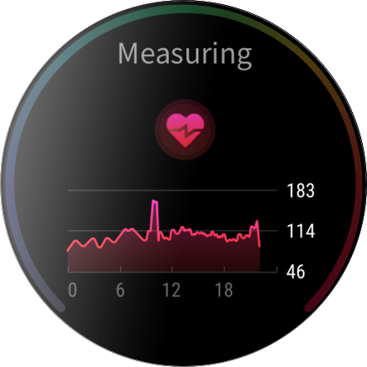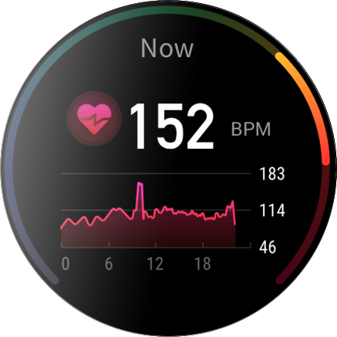

Sleep
Sleep quality has an critical impact on human health.
If you wear the watch while sleeping, it automatically records sleep information. You can synchronize sleep information to the Zepp app to view the sleep time, sleep stages, sleep score, and sleep suggestions.

Sleep Assistant
Keep your watch connected to your phone. Start the Zepp app, choose Profile > Zepp Z > Health Monitoring, and enable Sleep assistant for more accurate sleep information (REM sleep stage).

Sleep Breathing Quality Monitoring
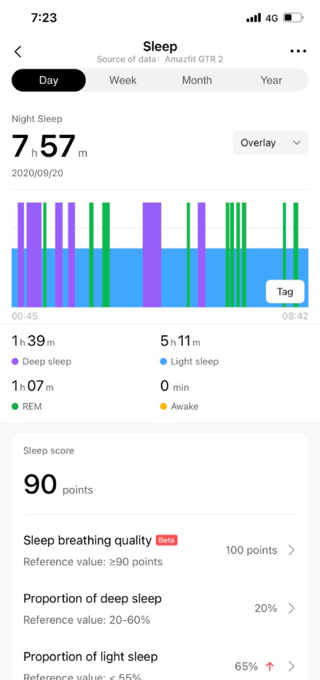
Keep your watch connected to your phone. Start the Zepp app, choose Profile > Zepp Z > Health Monitoring, and enable sleep breathing quality monitoring. The watch will automatically monitor your sleep breathing quality when you wear the watch while sleeping.

SpO₂
SpO2 is an important physiological parameter of respiration and circulation.
- Wake up the watch, press the digital crown to go to the app list, and select the SpO2 app to start measuring SpO2.
- When you are climbing a mountain, you can run the Workout app in the background, and start the SpO2 app to measure SpO2.
- After measurement is complete, the result will be displayed on the watch. You can also view measurement results for the whole day.

Precautions for SpO2 Measurement
- Wear the watch a distance of one finger away from the carpal and remain still.
- Wear the band tightly, with an appropriate sense of pressure.
- Place your arm on a tabletop or a stationary surface with the watch screen facing up.
- Remain still during measurement and focus on the measurement.
- Factors such as hair, tattoo, shaking, low temperature, and incorrectly wearing the watch may affect measurement results, and even lead to measurement failure.
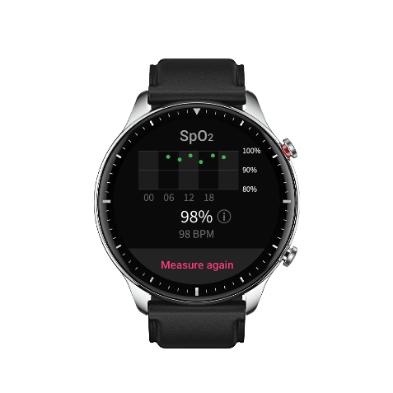
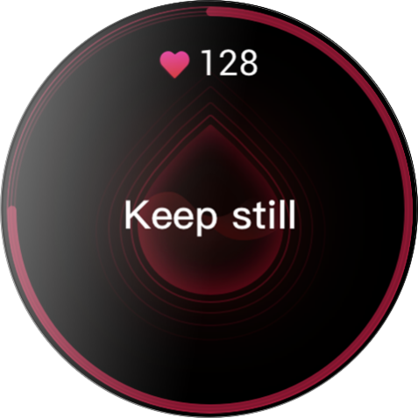
- The measurement range of this watch is 80%-100%. This function is for reference only and should not be used as the basis for medical diagnosis. If you feel unwell, please seek professional medical advice.

Stress
The stress index is calculated based on changes in heart rate variability. It is a reference for health status evaluation. You should rest more when the index is high.
- Wake up the watch, press the digital crown to go to the app list, and swipe up or down to select the stress app to view related information.
- When all-day stress testing is enabled in the stress app, stress will be measured every 5 min to show you the changes in your stress. You can also keep the watch connected to your phone, start the Zepp app, and choose Profile > Zepp Z > Health Monitoring to set this function.
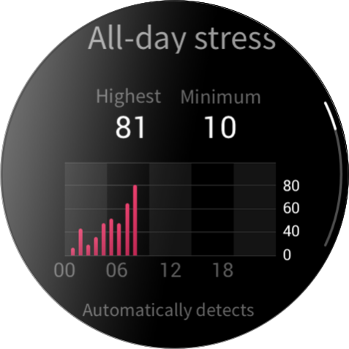
- When All-day Stress Monitoring is not enabled, you can access the stress app for measurement at any time and view and record the results.

Voice Function

Offline Voice
Offline voice control allows you to speak to perform most of operations on the watch without connecting to a mobile phone.
Offline voice wake up mode:
Settings > User preferences > Offline voice control > Wake up mode
- Respond within 5 seconds after you turn your wrist
- Respond within 5 seconds after the screen lights on
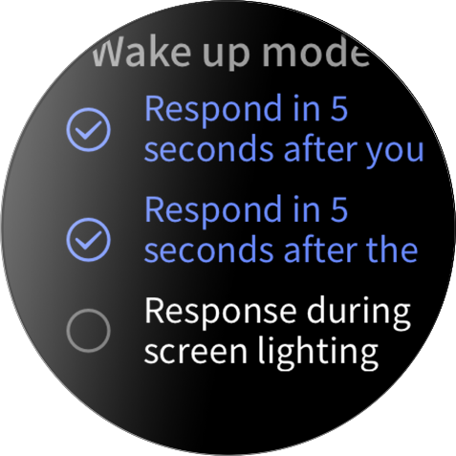
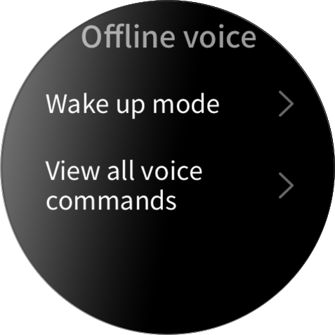
- Response while screen is active

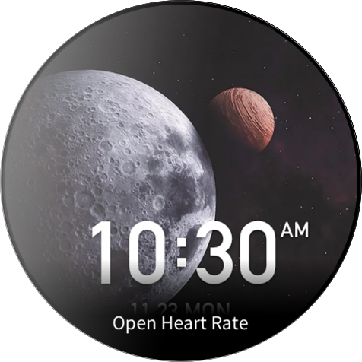
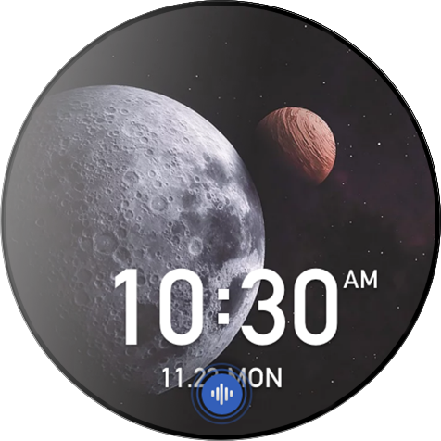
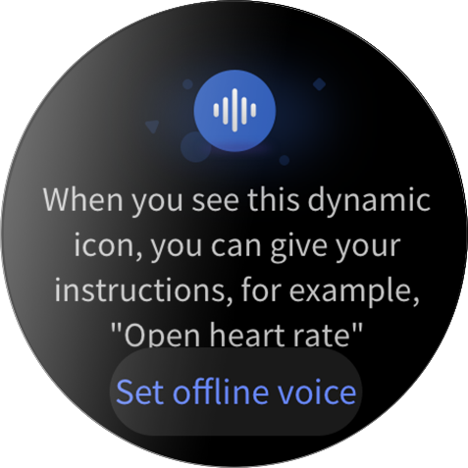
Select "Respond within 5 seconds after you turn your wrist" and "Respond within 5 seconds after the screen lights on" to enable offline voice. After turning your wrist or lighting the screen, the "Recognizing offline voice" icon appears. Then you can run offline voice commands to perform related operations.
If you select "Response during screen lighting" to enable offline voice, you can use offline voice commands directly before the "Recognizing offline voice" icon appears.
Offline voice commands words:
Settings > User preferences > Offline voice control > View all voice commands. Here, you can see all the offline voice command words the watch supports.
Note: The global version of Zepp Z watch currently supports offline voice function only when the watch language is set as Simplified Chinese or English.

Online Voice
Keep your watch connected to your phone. Start the Zepp app, choose Profile > Add Accounts > Amazon Alexa, and log in to the Amazon account to authorize Amazon Alexa. After successful authorization, press and hold the upper button for 1 second to enable online voice - Amazon Alexa.
After you enable the online voice function, you can ask questions such as “What is the weather?” and speak commands such as “Turn on the living room lights” to Amazon Alexa when you see the “Listening” status.
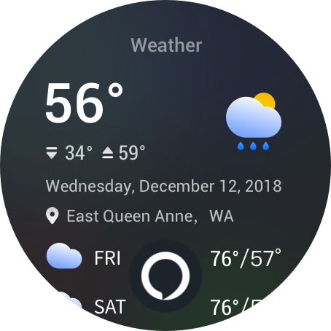

Music remote controller:
Keep your watch connected to your phone. When playing music on your phone, you can start or pause the music, switch to the previous or next one, and perform other operations on the music app of your watch.
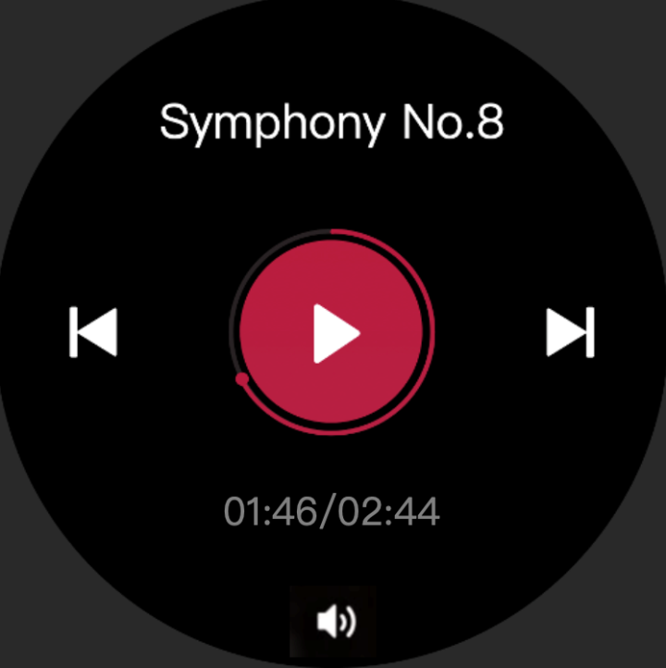
Modify settings on an Android phone:
Keep your watch connected to your phone. Start the Zepp app, go to Profile > Zepp Z > App List Management. On the page that appears, tap the "Can’t access notifications" message to go to the Notification Settings page, and grant notification permissions for the Zepp app. If this message is not displayed, the permission is granted.
Note:
If you want to use this function on a mobile phone running Android, add the app to the whitelist or the auto-run list, and keep the app running in the background. If the Zepp app is killed by the phone's background process, the watch will be disconnected from your phone and you cannot control music playback.

Watch Apps

Watch Apps
Apps refer to the watch functions that can be used separately, such as PAI, Heart Rate, SpO2 and Workout.
To use an app, wake up the watch, press the digital crown to go to the app list, swipe up or down to browse the app list, and tap an app to start it.
You can also set frequently used apps as quick access apps to facilitate your use.

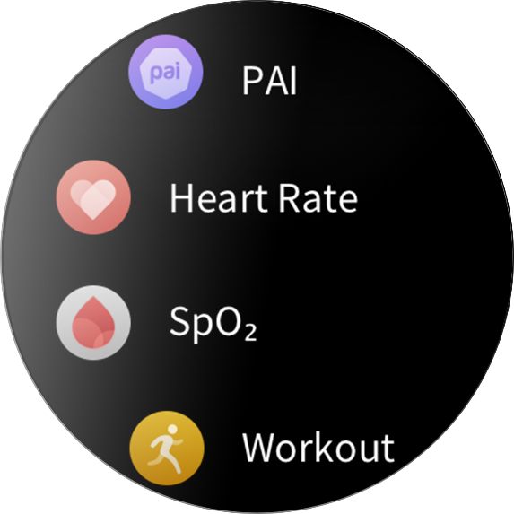

App List Management
Keep your watch connected to your phone. Start the Zepp app, choose Profile > Zepp Z > App List Management, and set apps that you can view on your watch.

Events
After you create a schedule, the watch will vibrate to remind you when the scheduled reminding time arrives.
Keep your watch connected to your phone. Start the Zepp app, choose Profile > Zepp Z > Events, and create or edit a schedule.
Wake up the watch, press the digital crown to go to the app list, and tap Events to view the configured schedules. Tap a configured schedule to edit its date and time.
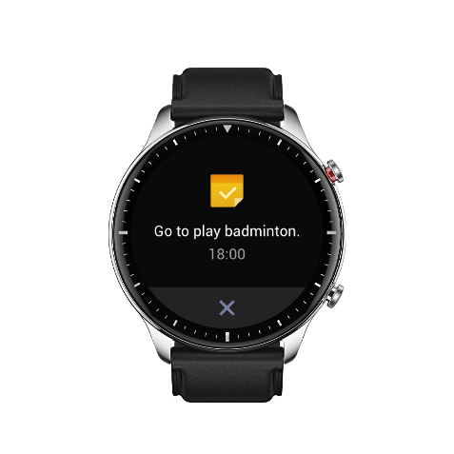
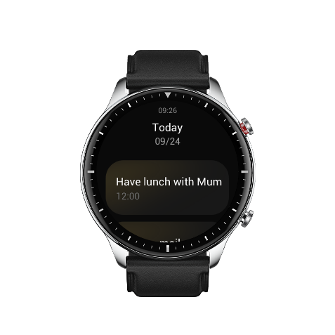

Weather
You can check today's weather, wind, humidity, UV intensity, and other information at any time, as well as the weather information for your current location for the next 7 days.
The weather data needs to be synchronized through the mobile network. Therefore, you need to keep the watch connected to your phone to keep weather information up to date.
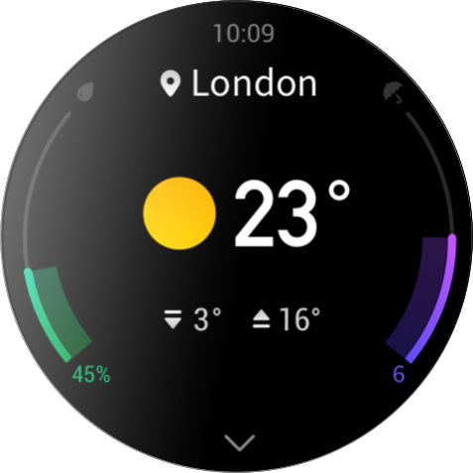
You can set the city and temperature unit (Celsius or Fahrenheit) in the Zepp app.

Compass
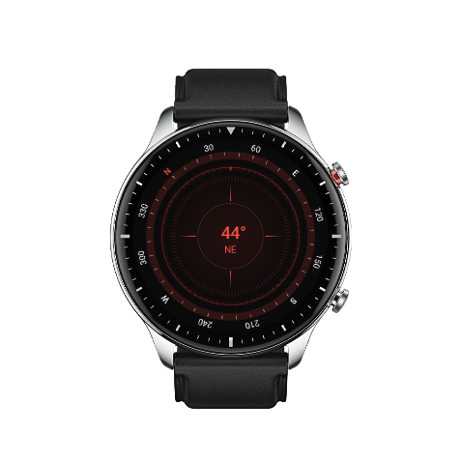
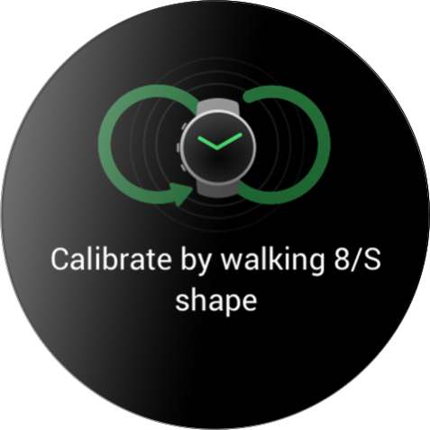
Before use, you may need to draw the shape of the number 8 to complete calibration. A reminder will appear prompting you to calibrate. After you finish calibration, the watch will display the current latitude and longitude of the watch and the direction it is pointing. To avoid interference and improve accuracy, keep the watch horizontal and keep it away from magnetic fields during use.

Barometric Altimeter
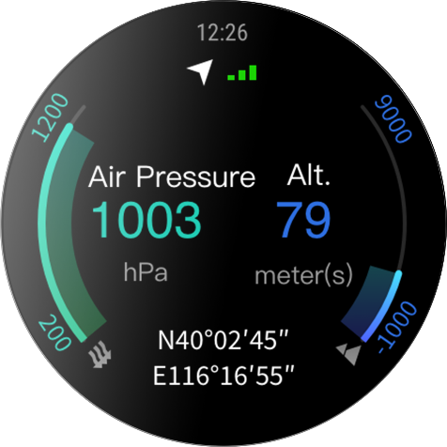
The barometric altimeter can show pressure and altitude information for your current position after positioning. After successful positioning, you watch displays the latitude and longitude.

Alarm
You can add alarms in the Zepp app and on the watch. Alarms can be repeated, enabled, or deleted. Press and hold alarms that are no longer needed to delete them.
When the preset time for an alarm arrives, the watch will vibrate as a reminder. You can instruct it to nap or turn it off. If you choose to nap, it will vibrate again after 10 min. You can only use this function 5 times per alarm.
If you do nothing when the watch vibrates, it will automatically turn on nap mode after 30 sec.
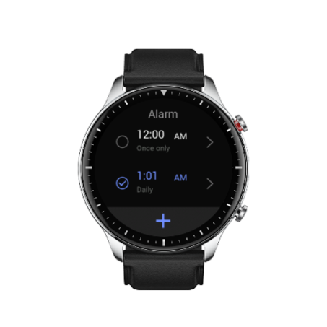

Timer
The watch provides a timer with an accuracy of 0.01 sec and a maximum recording time of 24 h.
The watch can count times while timing, and can record up to 99 times.

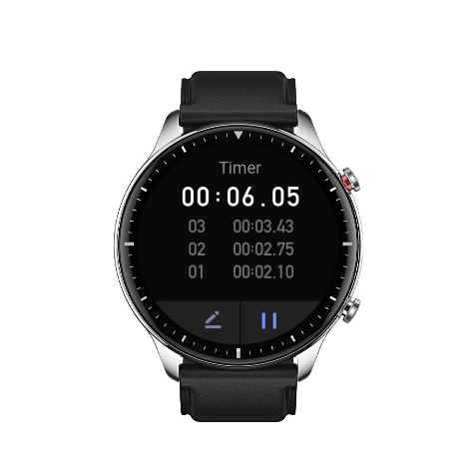
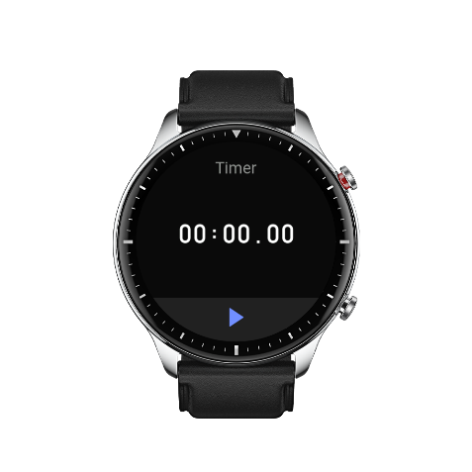
Countdown
You can set the countdown time. At the end of the countdown, the watch will vibrate as a reminder.
Watch Settings

System Language Settings
Start the Zepp app, then go to Profile > Zepp Z > Watch settings > System language to change the system language of the watch.

Wearing Direction
Go to Watch > App list > Settings > User preferences > Wearing direction, and set the button to be on the left or right of the screen for your wearing habit.
